1. Check Meta data of the three .wav files.

Notice Message_2.wav has a warning- corrupted.

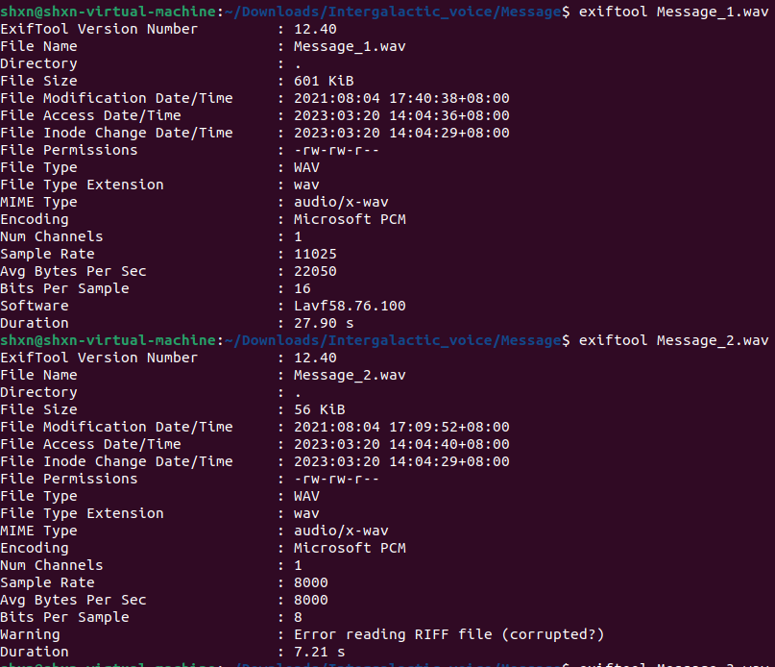

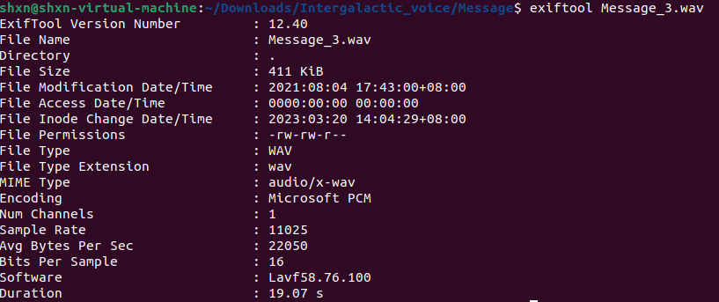

1. Recover Message_2.wav file using Sox. Sox is a powerful tool for sound processing and can be used to attempt to recover a corrupted WAV file.

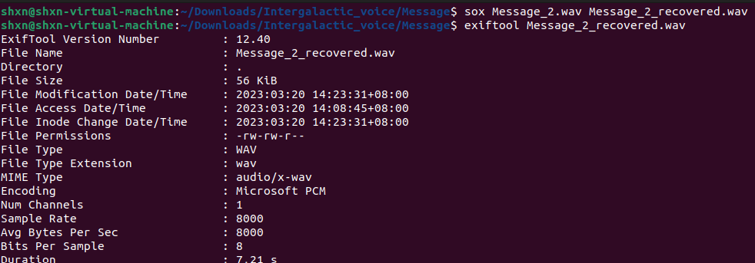

1. Run steghide to check if each of the files does contain some secret.

If the audio file contains hidden data, Steghide will prompt you for a passphrase. Enter the passphrase that you were given or that you suspect was used to hide the data.

